# First Moment: Mu (Average Annual Return)

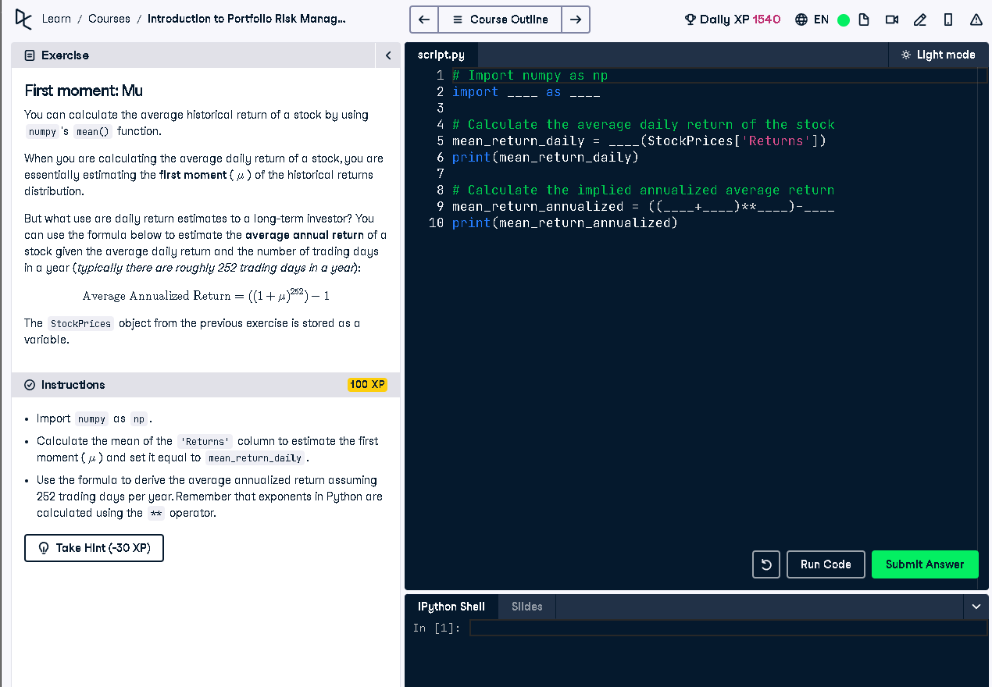

## Python Code

# Import numpy as np  
import numpy as np  
  
# Calculate the average daily return of the stock  
mean_return_daily = np.mean(StockPrices['Returns'])  
print(mean_return_daily)  
  
# Calculate the implied annualized average return  
mean_return_annualized = ((1 + mean_return_daily) ** 252) - 1  
print(mean_return_annualized)

## Explanation

This code calculates the average daily return of a stock using NumPy’s mean() function. It then estimates the average annual return by compounding the daily return over 252 trading days in a year. This is useful for investors to understand yearly return trends based on historical daily performance.